Sample Abstract for the PHITS workshop 2025

Tatsuhiko Sato1, Koji Niita2

*1. Nuclear Science and Engineering Center, Japan Atomic Energy Agency, Japan*

*2. Research Organization for Information Science and Technology, Japan*

This is a sample abstract for the PHITS Workshop 2025. You can present any results obtained using PHITS [1] at this workshop, even if they have already been published. The abstract should be limited to one page. You may include figures and references if desired. The first author is expected to present the content at the workshop. Please indicate your preferred presentation style (oral, poster, or no preference) when submitting the abstract. The abstract will be made publicly available on the PHITS website [2] before the workshop. Therefore, please do not include any figures that may have copyright issues.

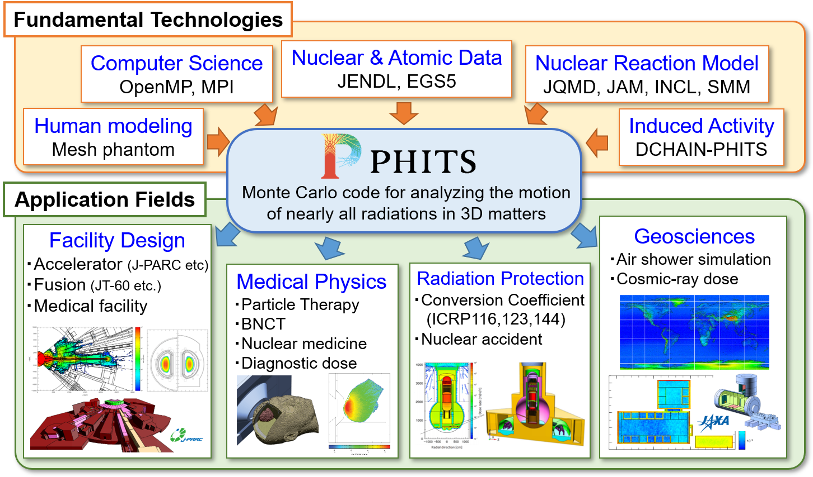

Fig. 1 Overview of the PHITS code

**References**

[1] T. Sato et al., Recent improvements of the Particle and Heavy Ion Transport code System - PHITS version 3.33, J. Nucl. Sci. Technol. 61, 127-135 (2024)

[2] PHITS website (<https://phits.jaea.go.jp/index.html>)